**Урок 5. Арканоид (Python, PyGame)**

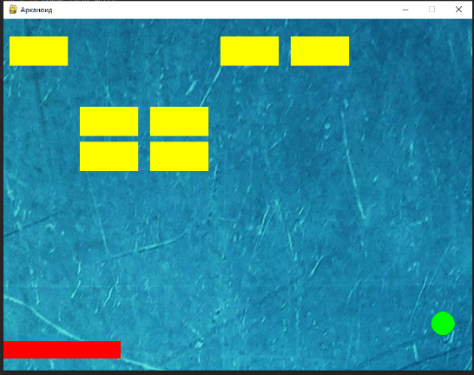 import pygame  
  
*# Settings*SIZE = W, H = (800, 600)  
FPS = 100  
ok = True  
speed = 10  
blocks = []  
dx, dy = 5, -5  
S = pygame.display.set_mode(SIZE)  
pygame.display.set_caption('Арканоид')  
clock = pygame.time.Clock()  
  
platform = pygame.Rect((W // 2, H - 50, 200, 30))  
ball = pygame.Rect(W // 2, H // 2, 20, 20)  
  
img = pygame.image.load('background.png').convert()  
  
  
for j in range(4):  
 for i in range(6):  
 b = pygame.Rect(10 + 120 * i, 30 + 60 * j, 100, 50)  
 blocks.append(b)  
  
while ok:  
 for e in pygame.event.get():  
 if e.type == pygame.QUIT:  
 ok = False  
  
 S.blit(img, (0, 0))  
 for i in range(len(blocks)):  
 pygame.draw.rect(S, 'yellow', blocks[i])  
  
 hit = ball.collidelist(blocks)  
 if hit >= 0:  
 blocks.pop(hit)  
  
 pygame.draw.rect(S, 'red', platform)  
 pygame.draw.circle(S, 'green', ball.center, 20)  
  
 ball.x += dx  
 ball.y += dy  
 if ball.left < 0 or ball.right > W:  
 dx = - dx  
 if ball.top < 0 or ball.bottom > H:  
 dy = -dy  
  
 keys = pygame.key.get_pressed()  
 if keys[pygame.K_LEFT] and platform.left > 0:  
 platform.left -= speed  
 if keys[pygame.K_RIGHT] and platform.right < W:  
 platform.left += speed  
 if ball.colliderect(platform) and dy > 0:  
 dy = - dy  
  
  
 pygame.display.update()  
 clock.tick(FPS)